CALL FOR NOMINATIONS FOR COINN BOARD OF DIRECTORS

COINN is seeking nominations for the following positions:

Vice-President
Responsibilities: Attend all meetings and teleconferences; Perform the duties of the President in the absence of the President; Perform the duties of the Treasurer in the absence of the Treasurer; Serve on subcommittees of the Council as required. Eligibility: Financial member of COINN (individual member or member of an affiliated association; Must have prior board experience or have served on the COINN board for a period of at least 12 months; Member in good standing; Demonstrated leadership ability at National level; Capacity to meet obligations and time commitments for the duration of the term of office (minimum two years).

Secretary
Responsibilities: Principal administrative officer of the Council and as such must keep minutes of: All appointments of office-bearers and non-executive directors of the board, and
the names of members of the board present at a board meeting or a general meeting, and all proceedings at board meetings and general meetings (ensuring minutes are signed by the chairperson of the meeting or by the chairperson of the next succeeding meeting; Arrange meetings of the board and membership in consultation with the President; Attend all board meetings; Conduct the Council correspondence. Eligibility: Financial member of COINN (individual member or member of an affiliated association; Must have prior board experience or have served on the COINN board for a period of at least 12 months; Member in good standing; Demonstrated leadership ability at National level; Capacity to meet obligations and time commitments for the duration of the term of office (minimum two years).

Non-Executive Directors at Large (non-office holding Directors)
Responsibilities: Attend all meetings and teleconferences; Assist in the development and publication of position statements on neonatal issues; They do not necessarily represent the voice of the national association in which they might be a member. Represent the voice of neonatal nurses and healthcare workers caring for newborns at an international level; Anticipate a good communication COINN messages directly with association; Advocate for COINN. Eligibility: Financial member of COINN (individual member or member of an affiliated association; Experience of sitting on national association executive board; Preferred to have prior board experience; Member in good standing; Capacity to meet obligations and time commitments for the duration of the term of office (minimum of two years).

If interested in a position, please complete the nomination form below: For any questions, please contact Carole Kenner, PhD, RN, FAAN, FNAP, ANEF, IDFCOINN at ceo@coinnurses.org
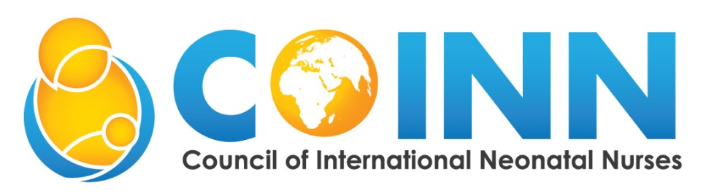

NOMINATION FORM for OFFICE HOLDER AND NON - OFFICE HOLDER DIRECTORS
to the COINN BOARD

I ________ACCEPT NOMINATION FOR THE POSITION OF _______ ON THE COUNCIL OF INTERNATIONAL NEONATAL NURSES, INC. (COINN) BOARD OF DIRECTORS.

Signature: Date:

Candidate questions for elections to the Board of Directors

Please, answer the following questions (no more than 2 pages). Attach your curriculum vitae or resume and provide contact information for your two nominators from the current COINN board (title/position and email/phone).

- Why are you interested in a COINN Board position?
- What is your vision for COINN and what activities would you undertake?
- What is your involvement with neonatal nursing, your national association or with COINN?
- What experience do you have in serving on national or international boards?

Please provide any other information to support your nomination should you wish.

Nominations to be received by 15-December 2023 and sent to ceo@coinnurses.org

